Appendix 2 Homework Problems

Problem A2.1

Determine the x and y coordinates of the centroid of the shape shown below via integration.

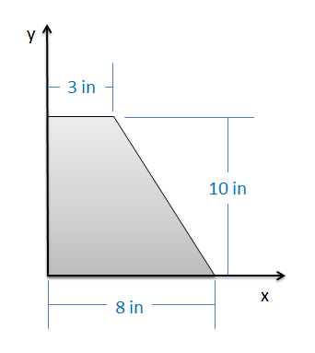

Solution: XC = 2.94 in, YC = 4.24 in

Problem A2.2

A water tank as shown below takes the form of an inverted, truncated cone. The diameter of the base is 4 ft while the diameter of the top is 8 ft. The height of the tank is 4 ft. If the tank is filled with water (assume a constant density) what is the z position of the center of mass of the water in the tank?

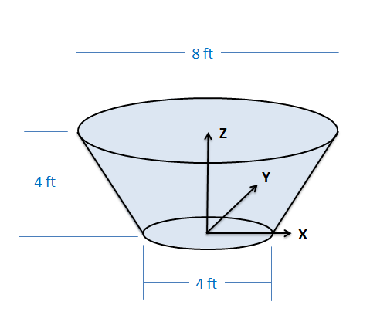

Solution: ZC = 2.43 ft

Problem A2.3

Use the method of composite parts to determine the centroid of the shape shown below.

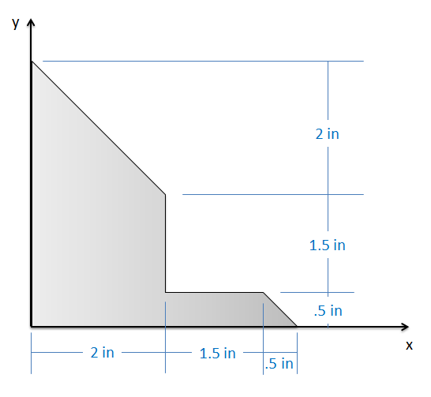

Solution: XC = 1.14 in, YC = 1.39 in

Problem A2.4

A floating platform consists of a square piece of plywood weighing 50 lbs with a negligible thickness on top of a rectangular prism of a foam material weighing 100 lbs as shown below. Based on this information, what is the location of the center of mass for the floating platform?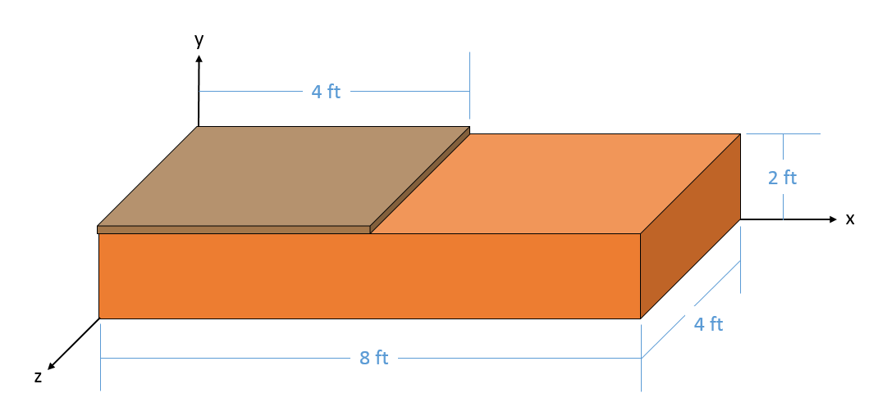

Solution: XC = 3.33 ft, YC = 1.33 ft, ZC = 2 ft

Problem A2.5

Use the integration method to find the moments of inertia for the shape shown below…

1. About the x axis through the centroid.
2. About the y axis through the centroid.

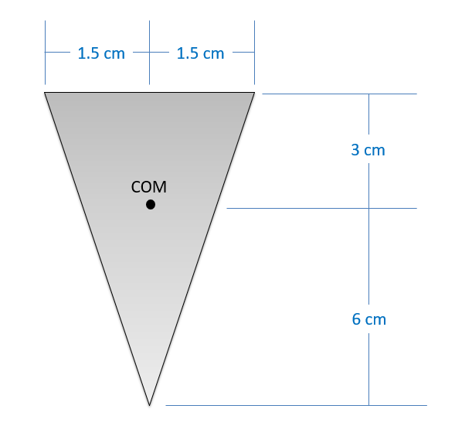

Solution: Ixx = 6.075\*10-7 m4, Iyy = 5.0625\*10-8 m4

Problem A2.6

A flywheel has an original weight of 15 pounds and a diameter of 6 inches. To reduce the weight, four two-inch diameter holes are drilled into the flywheel, each leaving half an inch to the outside edge as shown below. What was the original polar mass moment of about the center point? Assuming a uniform thickness, what is the new mass moment of inertia after drilling in the holes? (Hint: holes count as negative mass in the mass moment calculations)

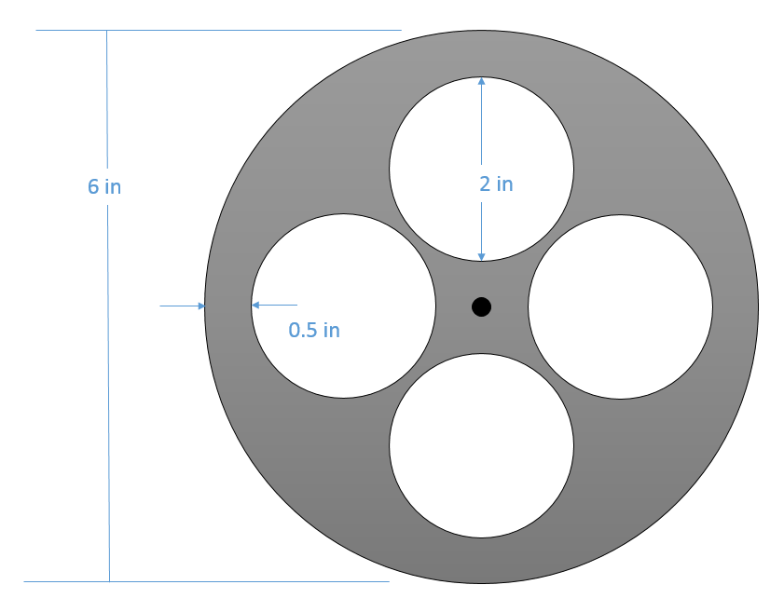

(Solution: Jwithout holes = .01456 slug ft2, Jwith holes = .01060 slug ft2)